5.3.2 Polar Worksheet

- Find the area of each of the following shaded regions.
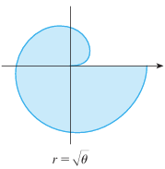 | We note here that r is never negative and so we can safely assert that
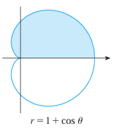 | We note here that r is never negative and so we can safely assert that
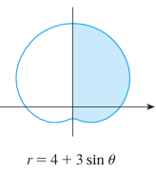 | We note here that r is never negative and so we can safely assert that
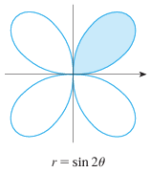 | We note that the first loop here is starts and ends when . This happens when (for some integer k). We note that and are the first values of where . Also on this range we note that r is never negative and so we can safely assert that

- Consider the polar curve . Find the area enclosed by one petal of this polar curve.

By symmetry we see that we can just find the area within the entire curve and then find of the result. Therefore the desired area is given by:
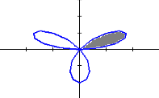

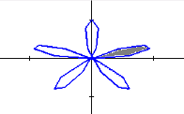
- Find the area of the region enclosed by one loop of

We note that when for some integer k. This means that the first petal is traced out as varies from 0 to . So the area enclosed by the first loop is

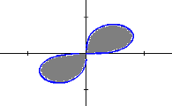
- Find the area enclosed by the polar curve

We first note that this function is undefined whenever . So to have we must have or . By symmetry we can state the area enclosed by the curve as

- Find the area which lies inside and outside .

We first find the intersection points between theses curves.
for some integer k.
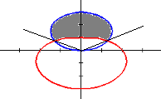
Therefore we are interested in finding the area traced out as varies from to . When facing this direction we see that is the “larger” curve. Therefore the desired area is
- Setup, but do not evaluate, an integral(s) that represent the area that lies inside the first curve and outside the second curve.
- and
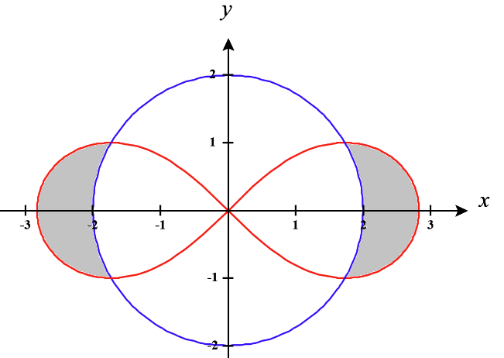
We note that the region is symmetrical and so we will only find the right portion of the shaded area and double the result.

We note that the curves intersect when
for some integer k.

Note that the angles indicated by the green dashed lines are . On this range of angles note that is the larger function and is the smaller function. Therefore, the total shaded area is given by .

- and

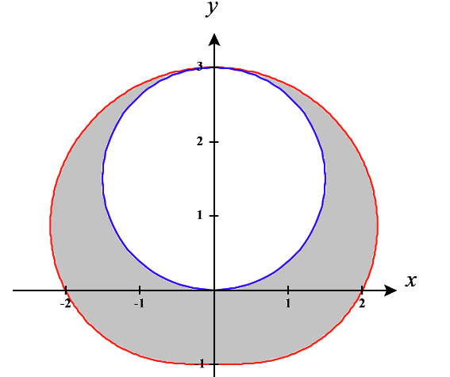
To find this area we plan to find the area inside the red curve and then subtract off the area within the blue curve.

We note that the curve always have non-negative values for r and therefore we can say that
We note that the curve is trace out as varies from 0 to and so we can say that

Therefore, we have that .

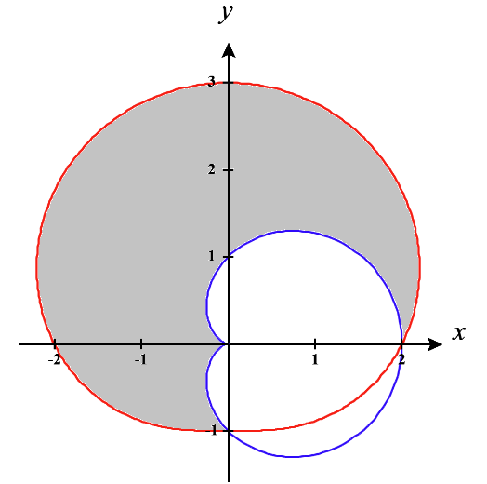
- and

- Find a way to compute this area by seeing it as an area between two curves.

Note that both curves never produce negative values for r and so when finding areas with these curves we never have to worry about shading “behind” the direction we are looking.

We see that the shaded area exists between the smaller blue curve and the larger red curve on the range of angles from to .

Therefore

- Find a way to compute this area by seeing it as an addition and subtraction of various areas. (That is differently than the way the area was computed in part (i)).

We plan to find the total area inside the red curve and the total area inside the blue curve. If we subtract the blue area from the red area we will have subtracted too much and can then add back on the sliver of area that exists within the blue curve and outside the red curve.

We compute that and
We also note that the area of the small sliver inside in the blue curve but outside the red curve is given by
Therefore,

- and
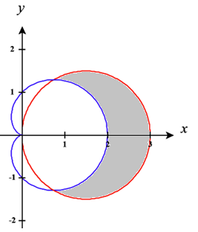
Note that both curves never produce negative values for r and so when finding areas with these curves we never have to worry about shading “behind” the direction we are looking.

The curves intersect when

Therefore we can state that the area is given by

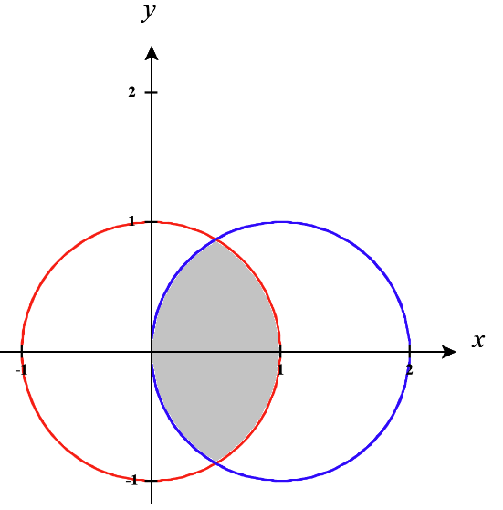
- and

We see that the intersection between these curves is given by

We will approach the problem by finding the area inside the blue curve between the values of and and then finding the area inside the red curve from to .

We have that .

- Setup, but do not evaluate, an integral(s) that represent the area of the region that lies inside both curves.
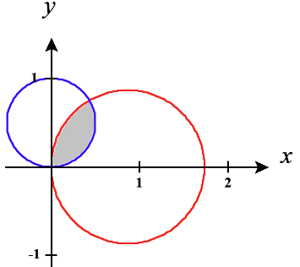
- and

We see that the intersection between these curves is given by

We note that both curves can produce negative values for r and so we have be careful that r remains positive on both functions over the range of angles that we plan to use.

We split the region into two regions and attempt to find the area of each.
We plan to find the area on the right (bounded by the blue curve from 0 to ) by computing .

We plan to find the area on the left (bounded by the red curve from to ) by computing .

Therefore, we have

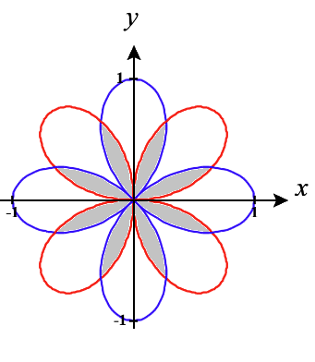
- and

We see that the intersection between these curves is given by

We note that both curves can produce negative values for r and so we have be careful that r remains positive on both functions over the range of angles that we plan to use.

We see that we have 8 regions of equal size and so we will plan to find the area of one of these regions and then multiply the result by 8. We look at the first region in the first quadrant. Plan to split this region into two regions and attempt to find the area of each region.

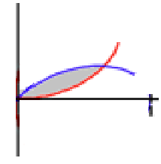
We plan to find the area on the right (bounded by the red curve from 0 to ) by computing .

We plan to find the area on the left (bounded by the blue curve from to ) by computing .

Therefore, we have

- and

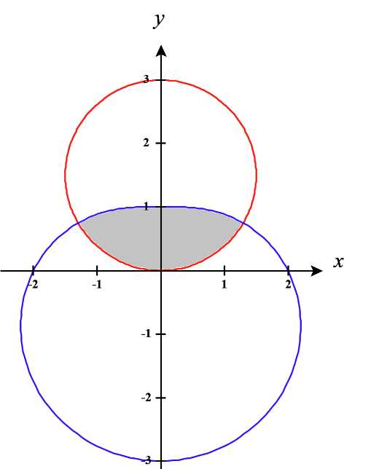
We see that the intersection between these curves is given by

We note that can produce negative values for r and so we have be careful that r remains positive on this function over the range of angles that we plan to use.

We will use the green lines in the picture to divide the shaded region into 3 separate spaces (left, right, and center).

We see that , , and .

Therefore, .

